**Name OF Team :-**

**------------------------**

1. ***Ahmed Moataz Sobhy sec 2***
2. ***Eslam Hamdy Abd EL Maboud sec 2***
3. ***Ahmed Mohammed Nagy sec 2***

**----------------------------------------------------------------------------**

**The First Screen that occurs to the user**

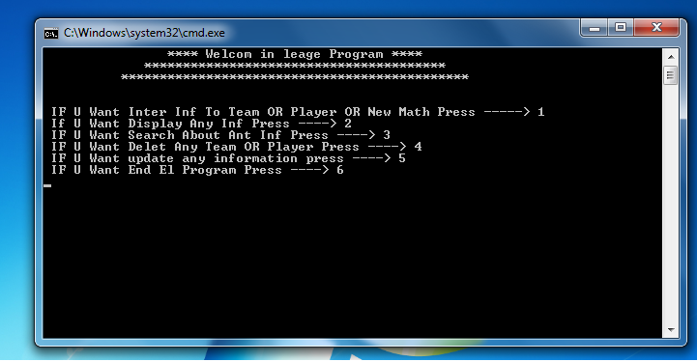

1 - Enter Information of team:-

------------------------------------------

You must Enter Information of team but IF you repeat

( ID or name ) OF team . it will appear message (that is found before ) and ask you to Enter different(ID or Name) .

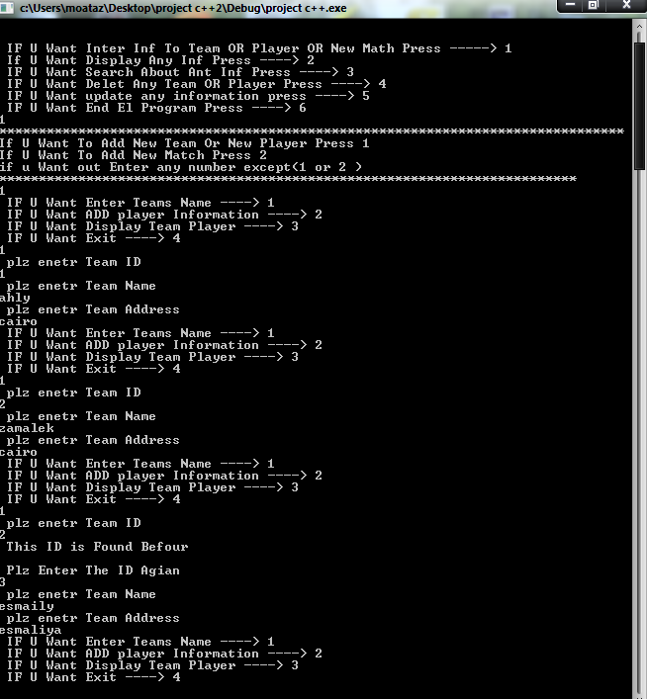

2- Enter Information of player

----------------------------------------

* You must Enter Information of Player but IF you repeat ( ID or name ) OF Player . it will appear message (that is found before ) and ask you to Enter different(ID or Name) .
* if you enter age of player more than 46 or less than 16,it will appear message (Error the age of player must be between(16 to 46 ) ).
* if you enter salary of player equal or less than 0 ,it will appear message (Error the salary of player must be more than 0 ).
* If you repeat number of t-shirt in same team it will appear message (that is found before ) and ask you to Enter different(number of t-shirt) .
* When you Enter date of birth you must Enter birth day and month, and it will appear message (he born in ……. ). Ie age of player 26 (he born in 1985)
* When you Enter personal identity card

You must Enter 14 number ,if you Enter less than 14 number it will appear message (this number less than 14 you must Enter 14 number ),(plz Enter the number again)

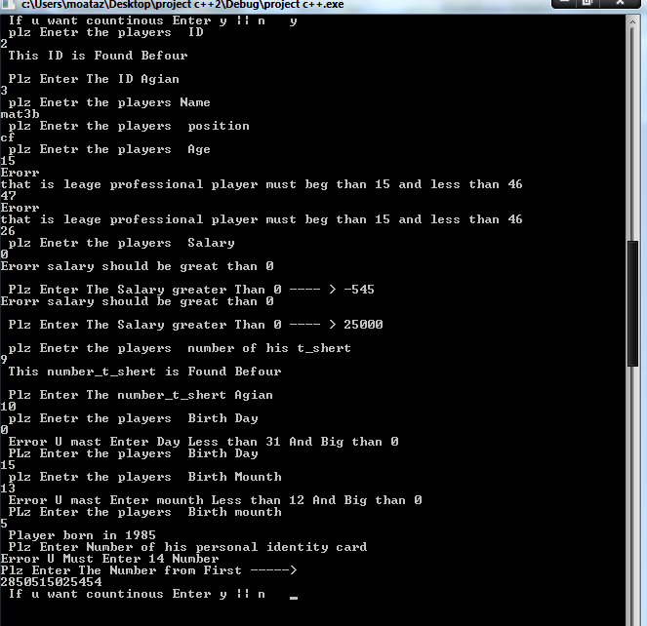

3- Enter result of match between two teams and the players who scored the goals

-------------------------------------------------------------------------

* When we choose (add a new match) we enter the Name of first team and the second team .
* Now we will enter the final result of this match and we will enter the players who scored in the match .
* If you enter player who did not found in the team it will appear message (this player not found plz enter it again).
* If the number of goals of the player in the first team less than the number of goals which the first team scored you will enter another player who scored in this match and so when the sumation of goals equal to the goals which the first team scored .
* We will do the same thing with the second team.
* If first team scored number of goals great than second team his point will increase 3 point and number of match his win increase 1
* 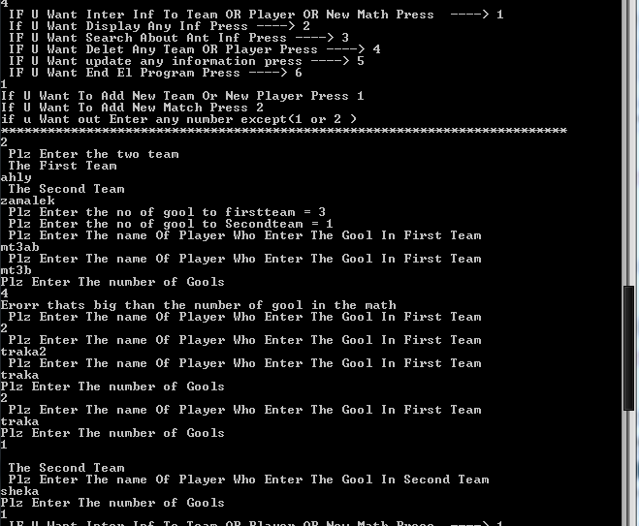

1. Update information of (teams or players)

-------------------------------------------------------------

* When you want to update player you choose team and then you choose player by the number in front of it, and then you choose what Do you want to update.

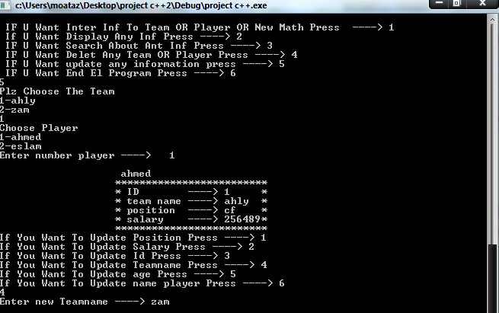

1. Display information Team , sorting by their points and

Top player by his goals

